**Assignment weeks 3, 4 and 5**

# *To answer all the questions below, you must use Stata (and, specifically, DASP, if requested). Be concise and clear in your answers.*

# *The assignment is divided into three exercises (the points assigned to each exercise are indicated next to each exercise). Please answer (A) directly in this file after each question (Q) and please attach the *.do file (do-file) that you generated. Rename both files as: “Assignment weeks 3-4-5 - Name, Surname”. Please submit this completed file and the *.do through the virtual drop box (boîte de dépôt) in the course portal, no later than Tuesday, February 23 11:59 p.m. (*[*Québec time*](https://www.timeanddate.com/worldclock/converter.html?iso=20190227T045900&p1=189)*).*

***Please, organize your do-file by exercise. Feel free to make your comments/discussions in the do-file.***

# Exercise 1 (4%)

Assume that the population is composed of six individuals belonging to two population groups, 1 and 2. The following table shows the distribution of incomes for three different periods.

|  |  |  |  |
| --- | --- | --- | --- |
| *group* | *inc1* | *inc2* | *inc3* |
| 1 | 2 | 16 | 2 |
| 1 | 4 | 16 | 4 |
| 1 | 18 | 16 | 18 |
| 2 | 4 | 32 | 2 |
| 2 | 8 | 32 | 4 |
| 2 | 36 | 32 | 18 |

* 1. For the distribution *inc1,* state whether the following statements are true or false and why.

1. Based on the *Scale invariance principle,* income inequality of group1 is equal to that of group 2. Input the data and check your answer by estimating the Gini index by population groups.

**A:**

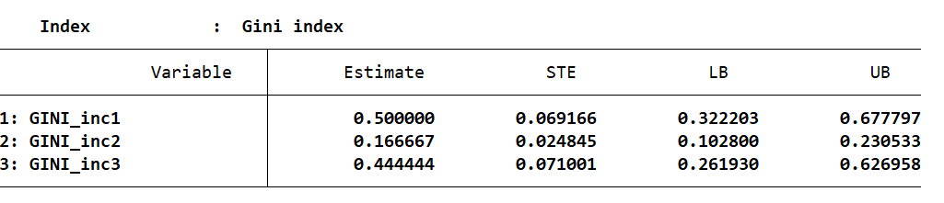

**FALSE - Because the mean difference of income inequality between first group and second group is different.**

**While using Gini index, we found the estimate between the group vary, hereby we observe estimate of 0.500000, 0.166667 and 0.444444 for inc1, inc2 and inc3 respectively.**

1. By considering the *Scale invariance principle* and the *Population principle,* the income inequality of the group1 is equal to that of the total population.

**A: TRUE - Because all income is scaled by a common factor and invariant to replication of population.**

1. The between group inequality of *inc1* is equal to that of *inc2.* Also, check this using the ***dentropyg*** DASP command (for theta=0).

**A: YES; Because the absolute contribution between the group inequality is the same for inc1 and inc2.**

1.2 Using the DASP command ***dentropyg***, decompose the entropy index (theta = 0). Do this for each of the three periods.

**A: (see in do file)**

1.3 Estimate the Gini inequality for each of the three distributions with the ***igini*** DASP command and discuss the results.

**A:**

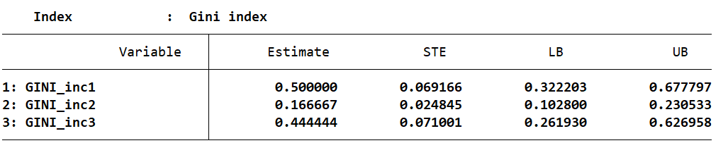

**The income distribution is 50%, 16% and 44% for inc1, inc2 and inc3 respectively. This means inc1 individual receives more percentage of total income in the population.**

# Exercise 2 (5.5%)

Assume that the population is composed of eight households.

|  |  |  |  |
| --- | --- | --- | --- |
| *identifier* | *pre_tax_income* | *hhsize* | *nchild* |
| 1 | 480 | 8 | 4 |
| 2 | 1200 | 10 | 6 |
| 3 | 460 | 6 | 4 |
| 4 | 2500 | 6 | 2 |
| 5 | 3800 | 8 | 2 |
| 6 | 560 | 8 | 4 |
| 7 | 1240 | 6 | 2 |
| 8 | 1760 | 8 | 6 |
| **Total** | **12000** | **60** | **30** |

The disposable income of the household is composed of three income sources:

1. post tax income = pre-tax income – income tax;
2. child allowances
3. Guaranteed universal income

The government perceives two potential scenarios (A and B):

* Scenario A: apply a proportional income tax of 10%. 60% of the total collected taxes are equally distributed across the population as a guaranteed universal income. The rest of the budget is redistributed equally across the population of children, as child allowances.
* Scenario B: apply a proportional income tax of 10%, and then redistribute equally the generate revenue across the child population. In that case, the guaranteed universal income is equal to zero.

2.1 Using Stata, input the data (the eight observations), and then generate the variables:

* *pcincatA:* per capita post tax income with the scenario A;
* *pcincatB:* per capita post tax income with the scenario B;
* *pcuincA:* per capita universal income with the scenario A;
* *pcuincB:*  per capita universal income s with the scenario B;
* *pcallowA:* per capita child allowances with the scenario A;
* *pcallowB:*  per capita child allowances with the scenario B;
* *dpcincA:* per capita disposable income with the scenario A (*pcincatA+ pcuincA+ pcallowA*);
* *dpcincB:* per capita disposable income with the scenario B (*pcincatB+ pcuincB + pcallowB*).

**A: (See in do file)**

2.2 Using the DASP command *igini*, estimate the inequality in the distribution of the per capita disposable income for each of the two scenarios.

**A:**

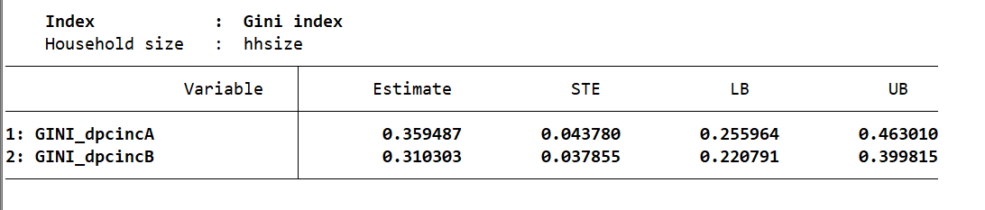

2.3 Using the DASP command *diginis*, decompose the inequality in the distribution of the per capita disposable income for each of the two scenarios (remember that the three income sources are *pcincatA, pcuincA and pcallowA* for the scenario A and *pcincatB, pcuincB and pcallowB* for the scenario B)*.*

**A:**

**Scenario A**

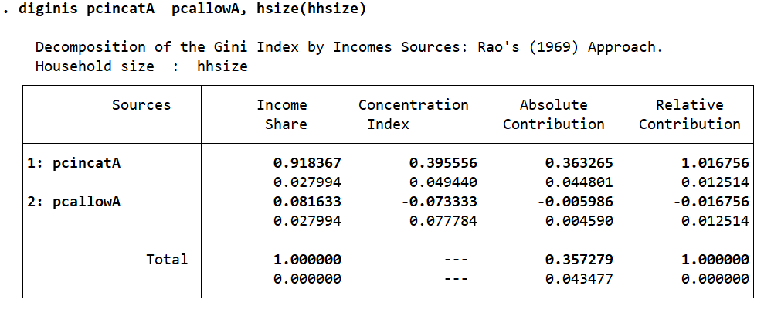

**Scenario B**

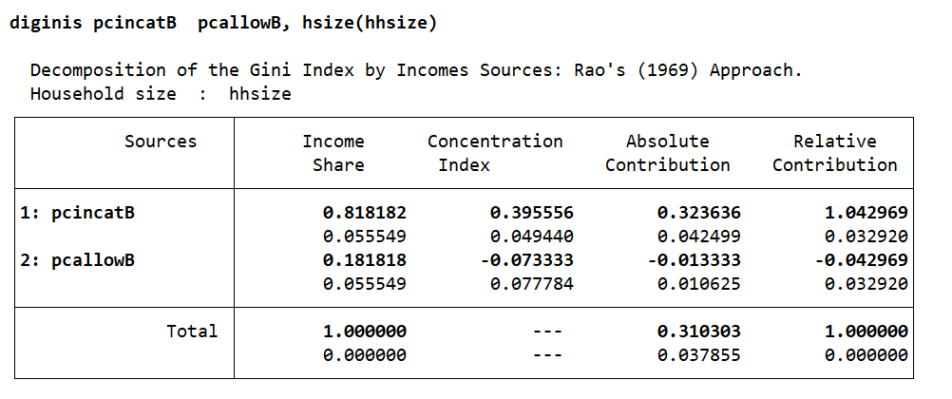

2.4 Based on the results of 2.2 and 2.3, in which case will the set of transfer programs reduce inequality in disposable incomes the most? Why?

**A: Case A is the mostly likely to reduce inequality in disposable income, since it has highest absolute contribution than case B. It gives contribution to both universal income of individual household and child allowance.**

2.5 Estimate the change in the headcount poverty under the scenario B (with respect to the initial distribution) when the poverty line is 100 (use the DASP command *difgt*).

**A:**

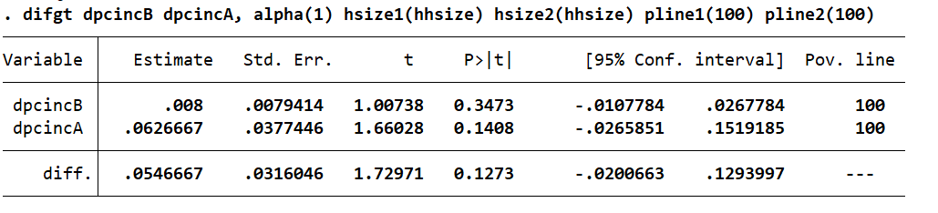

**Estimate change in the headcount poverty in scenario B is 0.79%**

2.6 With a poverty equal to 100, estimate the change in the poverty gap under scenario B (with respect to the initial distribution) (use the DASP command *difgt*). Discuss the found results in 2.5 and 2.6.

**A:**



**Estimate change in poverty gap is 5.5%**

# Exercise 3 (3%)

* 1. Load the file data_3, then initialize the sampling design with the variables *strata, psu* and *sweight*.

**A: (see in do file)**

* 1. Using the DASP ***ifgt*** command, estimate the headcount poverty when the measurement of well-being is the adult equivalent expenditures, and when the poverty line is equal to 21 000.

**A:**

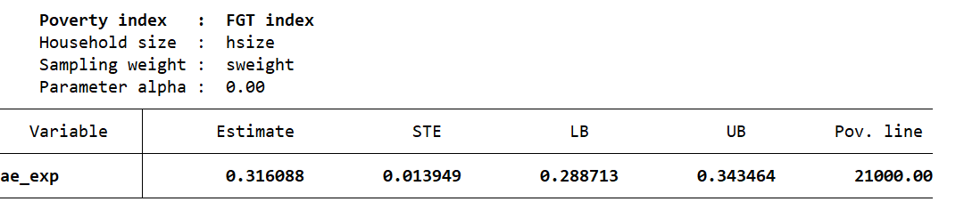

**The headcount poverty when adult equivalent expenditure is measurement of well being is 32%**

* 1. Now, estimate the headcount poverty by population groups (defined by the sex of the household head) and discuss the results.

**A:**

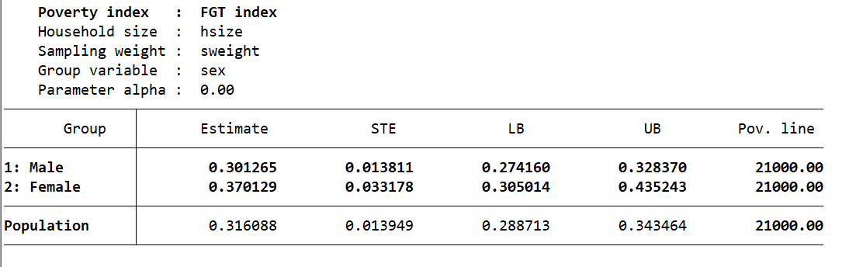

**For a given poverty line, majority of female are poorer than male since headcount poverty of female is higher than that of male when the adult equivalent expenditure is a measure of well being.**